**Flood Monitoring And Early Warning**

|  |  |
| --- | --- |
| **Date** | **10-10-2023** |
| **Team ID** | **539** |
| **Project Name** | **Flood Monitoring And Early Warning using IOT** |

**Table of Contents**

|  |  |
| --- | --- |
| 1 | Introduction |
| 2 | Problem Statement |
| 3 | Design and Innovation Strategies |
| 3.1 | Microcontroller |
| 3.2 | Sensors |
| 3.3 | GSM Module |
| 3.4 | Wi-Fi |
| 3.5 | Cloud Computing |
| 3.6 | Block Diagram |
| 3.7 | Protocol |
| 4 | Conclusion |

**1. Introduction**

This document seeks to delve into the core strategies and innovations driving the creation of a Flood Monitoring & Early Warning System. In a world facing increasing climate uncertainties, the need for precise flood monitoring and timely alerts is paramount. Our project aims to harness the power of Internet of Things (IoT) technology to build a robust system that continuously tracks water levels in flood-prone areas and issues real-time early warnings. Through innovative sensor deployments, predictive modelling, and data analysis, we aspire to enhance the accuracy of flood predictions, providing vital time for communities, emergency responders, and authorities to respond effectively to impending flood events.

**2. Problem Statement**

In regions susceptible to flooding, the need for a reliable Flood Monitoring & Early Warning System is undeniable. The central challenge of this project is to design and implement an IoT-based system that can accurately monitor water levels, weather conditions, and historical data to issue timely flood warnings. This system must contend with the complexity of flood prediction, taking into account numerous variables, and deliver early alerts that empower communities and authorities to mitigate the devastating effects of flooding.

**3. Design and Innovation Strategies**

**3.1. Microcontroller**

Common microcontrollers for flood monitoring systems include Arduino, Raspberry Pi, ESP8266/ESP32, and STM32 series. Selection depends on project complexity and communication needs.

* **Arduino**: Arduino boards, such as the Arduino Uno and Arduino Mega, are popular choices for their ease of use, a large community of developers, and a wide range of compatible sensors and shields.
* **ESP32**: These Wi-Fi and Bluetooth-enabled microcontrollers are suitable for remote monitoring and communication in IoT-based flood monitoring systems.
* **STM32 Series**: STM32 microcontrollers from STMicroelectronics are known for their high performance and a variety of communication interfaces, making them suitable for more advanced projects.

**3.2. Sensors**

Sensors commonly used in flood monitoring and early warning systems include water level sensors, rain gauges, weather stations, and occasionally, river flow sensors. These sensors provide critical data on environmental conditions, helping to detect rising water levels, heavy rainfall, and weather changes that are indicative of potential flooding.

* **Water Level Sensors**: These measure the water level in rivers, lakes, or reservoirs to monitor rising water levels, a key indicator of potential flooding.
* **Rain Gauges**: Rainfall data helps assess the intensity and duration of precipitation, which is crucial for flood prediction.
* **River Flow Sensors:** These sensors measure the flow rate of rivers and streams, providing insights into water discharge and potential flood risks.

**3.3. Global System for Mobile Communications**

GSM (Global System for Mobile Communications) modules are vital components in flood monitoring and early warning systems. These modules enable communication between the system and relevant authorities or the public. When triggered by sensors detecting potential flooding, a GSM module sends alerts via text messages or automated phone calls to designated recipients. It utilizes cellular networks to ensure broad coverage, allowing for timely dissemination of critical information. GSM modules provide a reliable means of communication, ensuring that warnings reach decision-makers and communities, enabling prompt responses to flood threats, and ultimately enhancing the effectiveness of early warning systems in safeguarding lives and property.

**3.4. Wi-Fi**

Wi-Fi connectivity plays a crucial role in flood monitoring and early warning systems. It enables seamless communication between various components of the system, such as sensors, microcontrollers, and central servers. Sensors collecting environmental data, like water levels and rainfall, can transmit this information to the central processing unit using Wi-Fi connections. The data is analysed in real-time to detect potential flooding. Wi-Fi ensures rapid data transfer and allows for remote monitoring and control of the system. It also facilitates the dissemination of alerts and warnings to relevant authorities and the public, contributing to timely responses and effective flood management in the event of an impending disaster.

**3.5. Cloud Computing**

Cloud computing is instrumental in flood monitoring and early warning systems by offering scalable and accessible data storage and processing solutions. Sensor data collected by the system, such as water levels and weather information, can be transmitted to the cloud for secure storage and analysis. Cloud-based platforms enable real-time data processing using powerful computing resources, allowing for accurate flood predictions and modelling. Additionally, cloud services facilitate remote monitoring, enabling authorities to access system data from anywhere. This centralized approach enhances the efficiency of early warning systems, as it ensures data integrity, scalability, and seamless collaboration among stakeholders, ultimately improving flood preparedness and response efforts.

**3.6. Block Diagram**

Note: In the diagram below, we have depicted the key components and interactions described in sections 3.1 to 3.5, offering a clear and concise overview of our solution architecture. This visualization simplifies the complex concepts and relationships discussed in those sections, making it easier for the reader to grasp the overall design and innovation strategies at a glance.

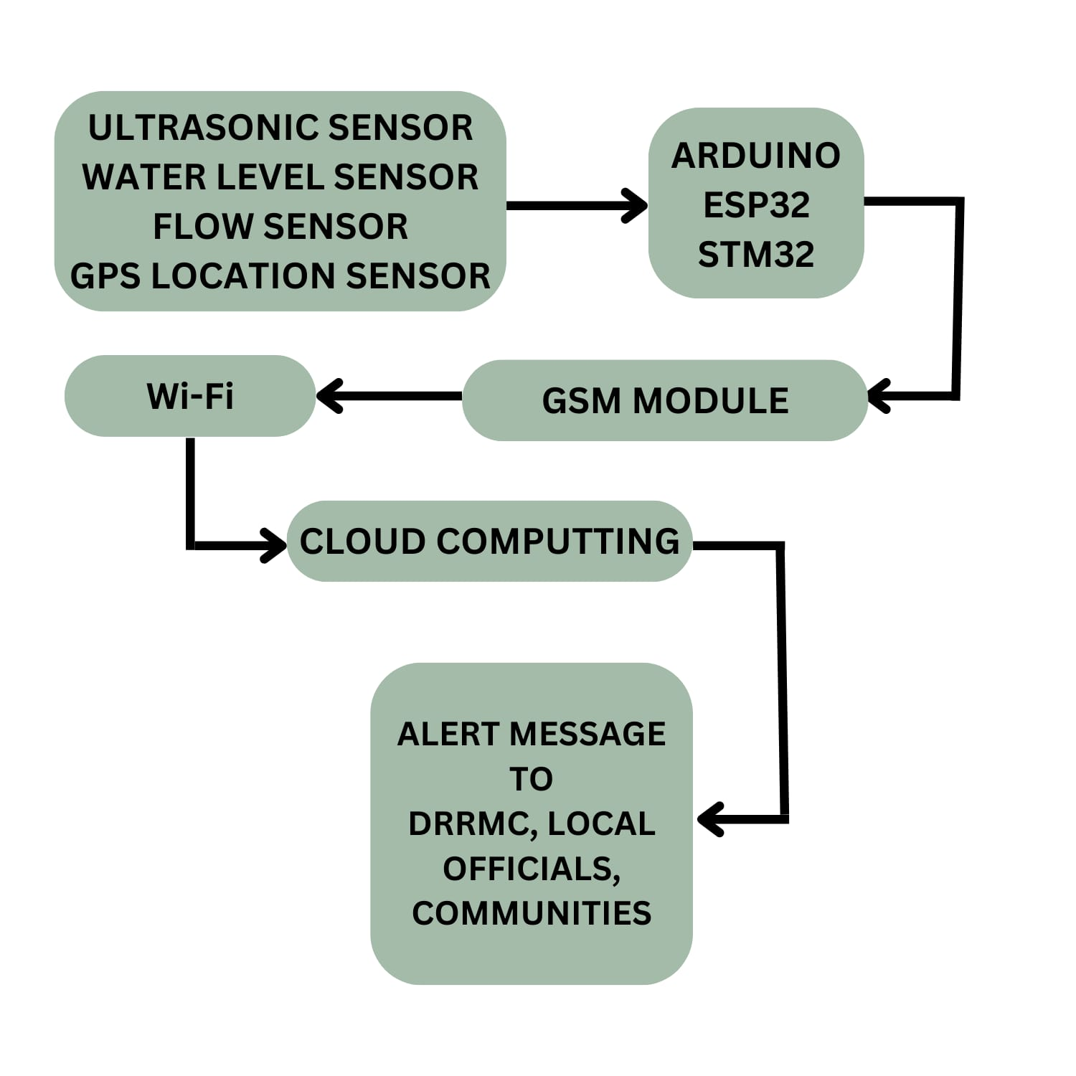

**3.7. Protocol**

**HTTP (Hypertext Transfer Protocol):**

* **Standard Web Protocol:** HTTP is a well-established and widely adopted protocol used for transmitting data over the internet. It's familiar and supported by most web servers and clients, making it accessible for developers.
* **Real-Time Data Transfer:** Flood monitoring systems often require real-time or near-real-time data transmission. HTTP can handle real-time data updates efficiently.
* **Compatibility**: It can be used with various devices, including microcontrollers, sensors, web servers, and mobile applications, making it versatile for integrating different components of the system.
* **Security:** HTTPS (HTTP Secure) can be implemented to encrypt data transmission, ensuring the security and integrity of the information being sent between system components.
* **Implementation**: HTTP libraries and frameworks are readily available for various programming languages, simplifying the development process.
* **Web-Based User Interfaces**: HTTP is suitable for creating web-based user interfaces, allowing users to access flood data through web browsers or mobile apps.
* **Request-Response Model**: HTTP follows a request-response model, which can be useful for querying data from remote sensors or servers and receiving timely updates.

**4. Conclusion**

In this document, we have outlined our design thinking approach to addressing the challenge of flood monitoring and early awareness using IoT technology. By empathizing with users, defining clear objectives, ideating innovative solutions, prototyping, testing, implementing, and iterating, we aim to develop a robust and user-friendly system that enhances early flood warnings and supports emergency response efforts. Our ultimate goal is to contribute to the safety and resilience of communities in flood-prone areas by providing timely and accurate flood data.